**Assignment No- 3**

1..Write a program that demonstrates widening conversion from int to double and prints the result.

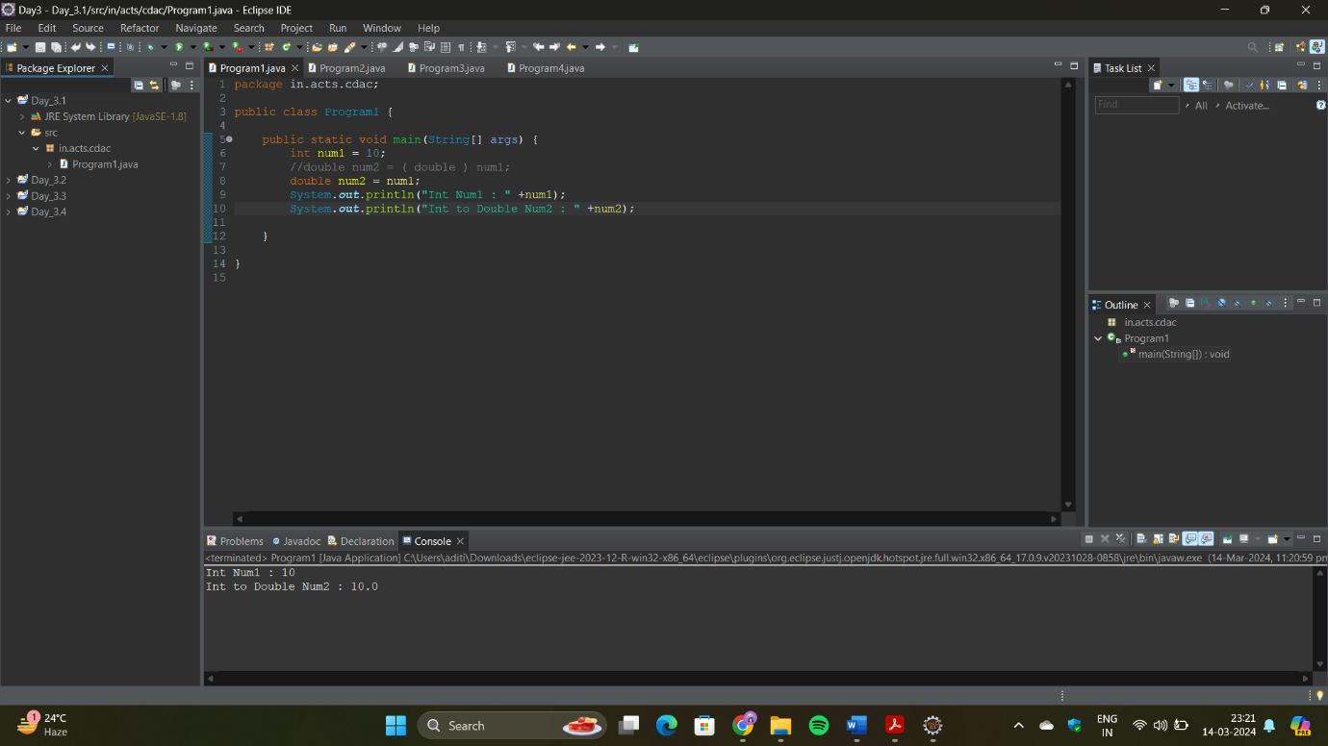

2..Create a program that demonstrates narrowing conversion from double to int and prints the result.

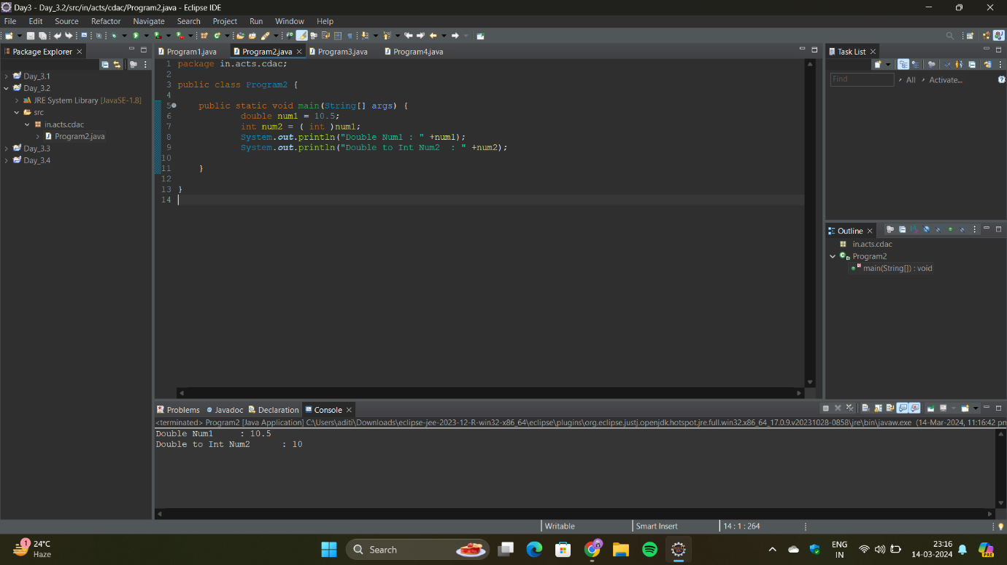

3..Write a program that performs arithmetic operations involving different data types (int, double, float)and observes how Java handles widening conversions automatically.

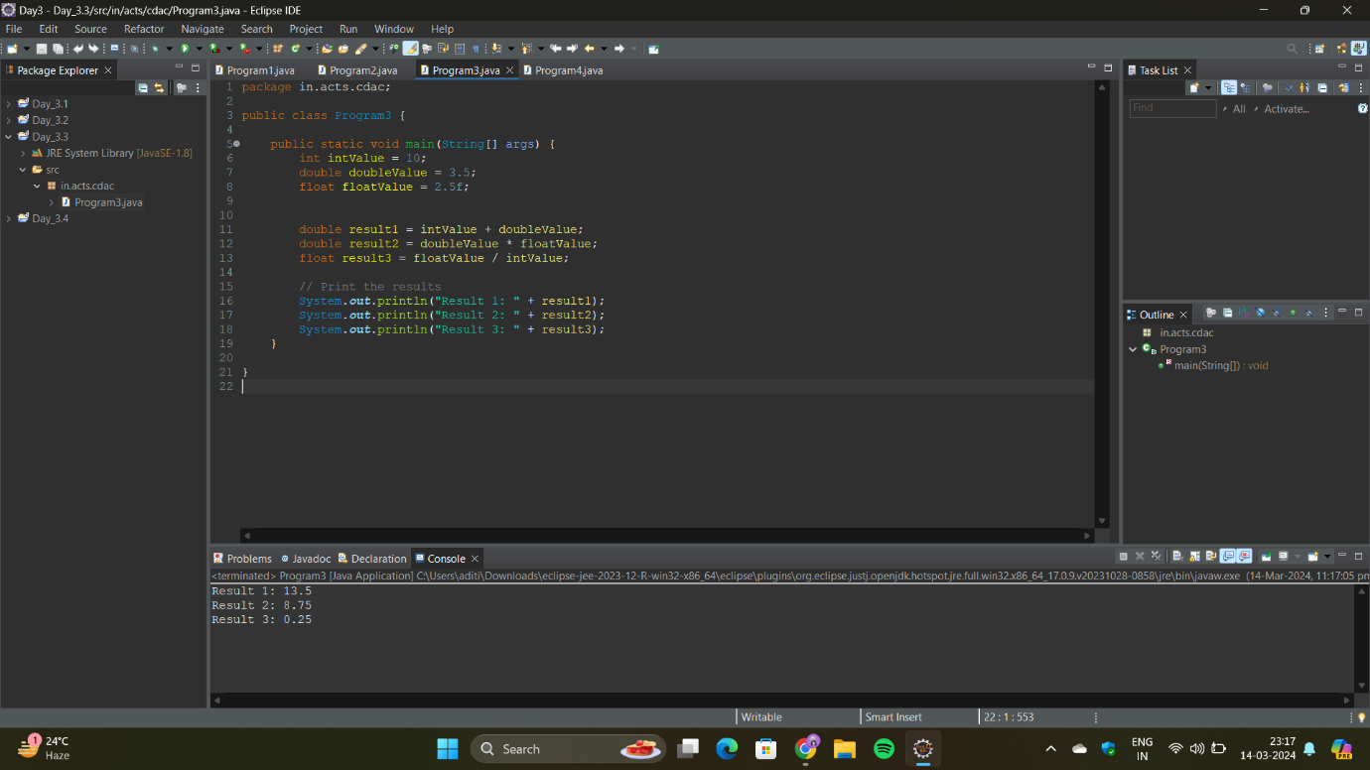

4..Write a Program that demonstrates widening conversion from int to (double,float, boolean, string) and

prints the result.

